HSWCD Annual Meeting  (Harney Soil & Water Conservation District)  When  February 27, 2025  6 to 8 pm  Where  Historic Central Hotel (171 N Broadway, Burns)  Audit report and presentation | Buffet provided by The Feed Barn  (rSVP by February 20th)  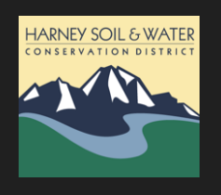  www.harneyswcd.org  Door Prizes  - Charlotte Ganskopp  - Dave Ganskopp  - CWMA  - The Bird Stop  - HSWCD

