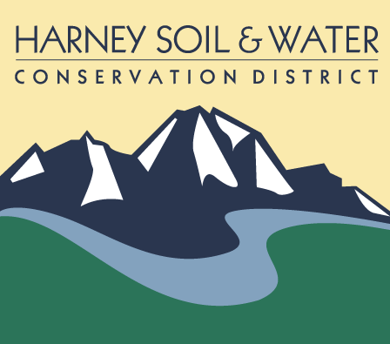

PO Box 848

530 Hwy 20 South, Hines OR 97738

Phone: 541-573-6446 [admin@harneyswcd.net](mailto:admin@harneyswcd.net)

**Harney Soil & Water Conservation District**

**Special Monthly Meeting**

**Remote**

**March 21 2024**

Note:  This meeting was held remote, but there were people present in the conference room at the USDA Service Center.

Present in the conference room:  Vice Chair (VC) Scott Franklin, Board Director (BD) Susan Doverspike, District Manager (DM) Jason Kesling, Sage grouse Coordinator (SGC) Sarah Mundy, CWMA Coordinator Tyler Goss, Admin Assist (AA) Barbara Pearson

Present, remote: Board Chair (BC) Jeff Hussey, Secretary/Treasurer (S/T) Ryan Peila, BD Stacy Davies and BD Ken Bentz

Present, remote guests: Lowell Goold from O-O Contracting, Todd Donahue from III Peaks

BC Hussey called the meeting to order at 3:30 pm.  He turned the meeting over to DM Kesling.

**Item #1—Approval of Meeting Agenda (action item)**

DM Kesling added public comment sessions as agenda items 1a and 2a.  VC Franklin moved to approve the updated meeting agenda.  All present who was eligible to vote were in favor.

**Item #1a—Public Comment.**

No public were present at the meeting during this time.

**Item #2—SOWR II Juniper Removal Bid Selection (action item)**

The HSWCD board was provided copies of submitted bids.  DM Kesling said seven bids had been received.  To aid in the discussion CWMA Goss and SGC Mundy used the conference room white board to create a spreadsheet.  DM Kesling said the Oregon Department of State Lands declined to provide input for the decision, advising it would go along with the board’s decision.

At 3:51 pm Lowell Goold of O-O Contracting joined the meeting.  He was advised there would be a public comment time following.

At 3:54 pm Todd Donahue from III Peaks joined the meeting.

Following discussion BD Doverspike moved to approve awarding the bid amount of $513,360 for state and private land submitted by O-O Contracting, and for the residual funds to be used for additional projects in the near future.  BD Bentz seconded.

DM Kesling requested the vote be recorded:  Those in favor were BD Doverspike, BD Bentz, and BD Davies; VC Franklin and S/T Peila voted aye; BC Hussey abstained.  The motion passed.

**Item #2a—Public Comment**

Todd Donahue asked about piling in the State Lands area and was told no machinery is to be used.  He asked if the bid results will be made public.  DM Kesling said the district has a public records policy and the results can be available for a fee.  VC Franklin and BD Doverspike both thanked Mr. Donahue and his company for submitting a bid.

Mr. Goold suggested in the future the district offer different contracts for different treatment types in bid project area.  SGT Mundy said in the future she will attempt to create units that require one treatment type. Mr. Goold further said there should be one contract for one project.  DM Kesling said it could be argued that each unit could be a separate contract; there was one bid tour.  The “all or nothing” clause in the bid documents dealt with each unit. He will contact the Oregon Ethics Commission and the Oregon Department of Agriculture for clarification.

Mr. Goold said even if his business won this bid it shouldn’t preclude him from being awarded future bids.

BD Doverspike thanked both vendors present for a clear, concise, and complete bids.

Mr. Donahue thanked the board for being able to spend the day with the district on the bid tour and said he would try to be more competitive for future bids.

**Item #3—NCD Urban and Community Grant Resolution (action item)**

DM Kesling provided background for the application.  The High Desert Partnership and district have both worked on this grant application for NACD. The district has applied for this grant in the past.  The application requires a board resolution.  The application deadline is April 1st.  The grant will fund a part time HSWCD employee, working toward food sovereignty in Harney County, partnering with other organizations to feed the community, develop a local food supply chain, and start up a CSA to reach a broader audience than the local farmer’s markets.  The DM said local farmers aren’t making connections with consumers.  The CSA would include eggs, beef, and pork.  BD Doverspike asked if there would be a liability for the producer and DM Kesling said it’s not known at this time.  There is currently no structure to the CSA—the funding would help establish this.

DM Kesling told the board the grant information provided to them prior to the meeting will be polished and additional information will be added, but “the bones won’t change.” He expanded on the term food sovereignty.  BD Doverspike asked about measurable goals.  Currently Kellie Frank is a part time employee with the HDP.  DM Kesling said food security is part of the district’s five-year plan and a local market is a goal.  BD Davies moved to approve submission of the grant application; BD Bentz seconded.  All present who was eligible to vote were in favor and the motion was approved.  DM Kesling advised BC Hussey and S/T Peila they will need to sign the resolution prior to the application’s submission on April 1st.

**Item #4—Adjourment (action item)**

BD Doverspike moved, and VC Franklin seconded adjourning the meeting.  All were in favor.  The meeting ended at 4:48 pm.

Respectfully submitted,

Barbara Pearson, Admin Assist

|  |  |  |
| --- | --- | --- |
| _____________________________________ |  | ____________________________ |
| District Representative |  | Date |