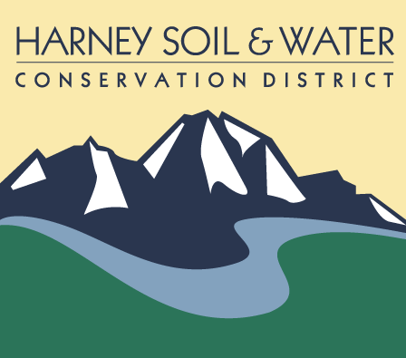

PO Box 848
530 Hwy 20 South, Hines OR 97738
Phone: 541-573-6446 admin@harneyswcd.net

HSWCD Special meeting
November 7, 2023
Remote

Present: Board Chair (BC) Jeff Hussey, Vice Chair (VC) Scott Franklin, Board Directors (BD) Ken Bentz and Carol Dunten; District Manager (DM) Jason Kesling and Admin Assist (AA) Barbara Pearson

The meeting was held remote. Its purpose was to review and vote on extending permission to the DM to send a rezoning proposal draft to ODA. If approved, the proposed change could be formally adopted at the December 14, 2023 meeting.

Jeff called meeting to order at 10:06 pm.

Participants were asked if they had the opportunity to view materials. DM Kesling provided an overview as to what he did with the mapping: Zone 3 and 5, moved to township that made the most sense. Zone 2 moved to highway and over to Burns, went down to the road into town. These changes will allow to allow more eligible people to serve on the board. There were no public comments.

VC Franklin moved and BD Bentz seconded approving the zoning change proposal to ODA for formal adoption at the December 2023 meeting. All present who were eligible to vote (BC Hussey, VC Franklin and BD Dunten and Bentz) were in favor.

Upon that decision VC Franklin moved and BD Bentz seconded meeting adjournment. All present eligible to vote were in favor.

The meeting ended at around 10:15 pm

Respectfully submitted,

Barbara Pearson, Admin Assist

_____________________________________ |  | ____________________________
District Representative |  | Date

