|  |  |
| --- | --- |
| When  Thursday February 23, 2023  5:30 pm - 8:00 pm  Where  Historic Central Hotel  171 N Broadway, Burns  What  Audit Report  Local Conservation Achievements  Guest Speakers | Dinner  Tri-tip buffet  provided by  Kathi Wenick  *RSVP by February 17th  (limited to first 35 who RSVP)  Door prizes by   * ACW Rental * Charlotte Ganskopp * HSWCD * HCWMA * Dehen 1920   Special Recognition   * Partner in Conservation |

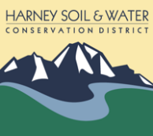

Harney soil & Water Conservation District

Annual Meeting

ANNUAL MEETING